Software

In the beginning, we met up with one of the seniors of the team that was the lead software. He was graduating and moving onto college. We met up with him and he helped us learn some java (basically the concepts), we had a few weeks before he left. We gathered up information from him as much as we could.

After he left we didn't really know what we were doing until we started watching and reading turtorials on the FIRST website. They explained it easier and it was easy to understand. After that we made some test programs for teleop to try it out, we tested a program for just servos and then tested a program for just motors. We got them to move! Then we did some autonomy test programs, it drove the robot in a square. Then we started on the competition teleop! We programmed six motors and two servos, We are trying to test out sensors. We made a simple autonomy to drive and park in the floor goal for the competition for now, but we are working on sensors such as the color sensor so that we can improve the autonomy.

Overtime we kept improving, there was some bumps in the road along the way but we got passed them! We kept learning and improving! I will get more into details in the next pages, let me show you what we have done this season and what we've learned!

This is one of the first programs we created to test out. We named it “SaladQueen” for fun. This program is to try out tank mode, which is where it uses both joysticks on one controller used for the drive. So when you use the left joystick it will move the left side of the robot and when you use the right joystick it will move the right side of the robot. When you push both of them forwards it will move both sides of the robot forwards. When you pull back both of the joysticks back it will move both sides of the robot backwards.
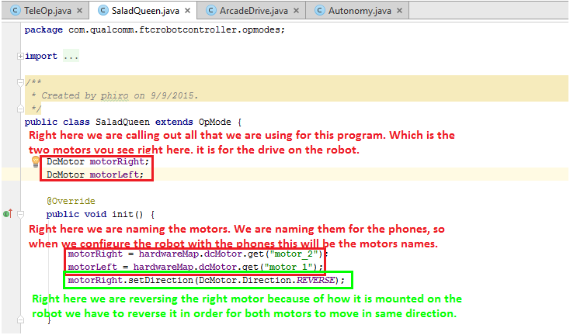
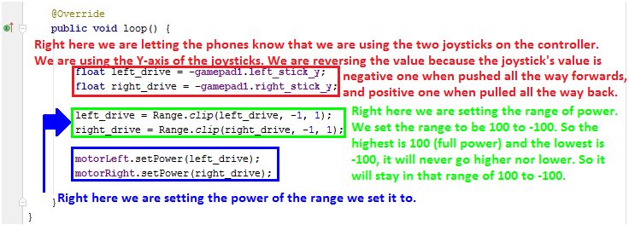

We named this program “ArcadeDrive”, in this program we are driving in arcade mode. We told you about tank mode, well arcade mode is different then tank mode. Let us explain arcade mode, arcade mode uses only ONE joystick, the left joystick controls the whole drive of the robot. It uses the X-axis and the Y-axis; the Y-axis is used for forwards and backwards, the X-axis is used for turning left and right. For competiton we use only use one controller so we use the arcade mode because we have more room to program other functions to the controller.
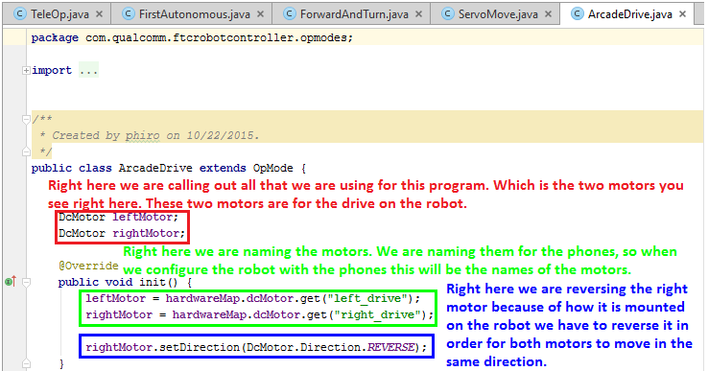
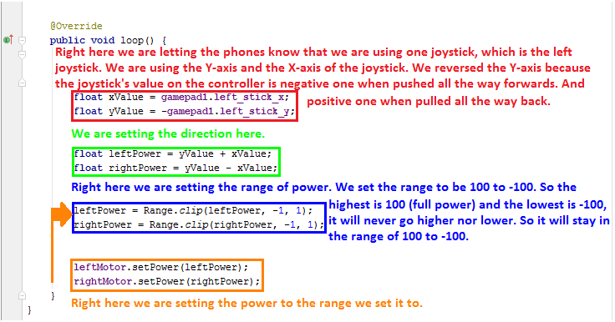
This is one of the test programs. In this program we were testing out two servos. We explained it better in the picture below.
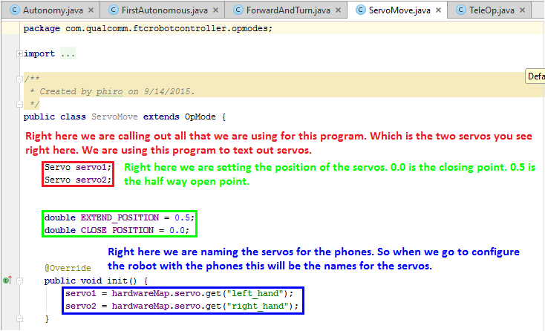
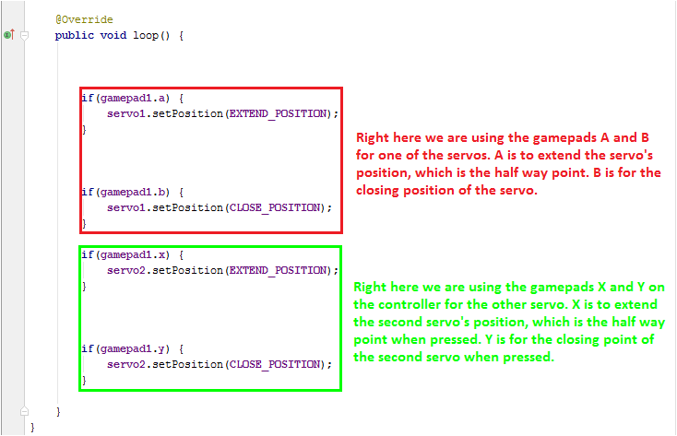
This was a test autonomy program, it is named “FirstAutonomous”. In this program we were only moving the robot forwards.
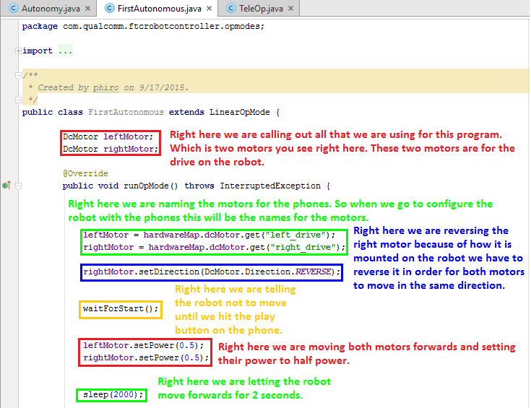
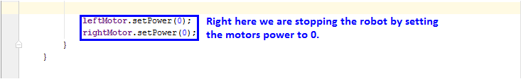

This is one of our competition autonomy, it is named “Autonomy”. This one is for when we are on the blue alliance. In this program we are moving the robot forwards and turning right, then we go forwards towards the floor goal and then we park on the floor goal. This is what we have for now but we are trying at the moment to improve and add more to this program to do more obstacles.
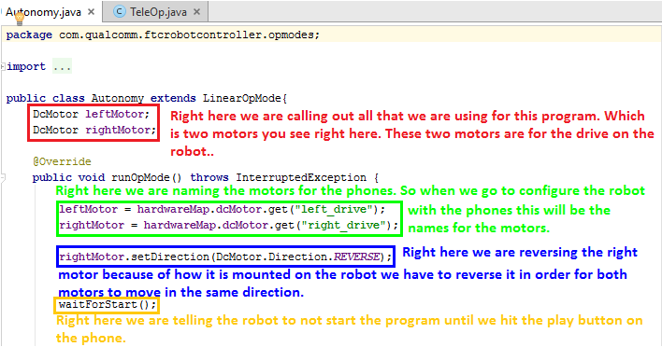
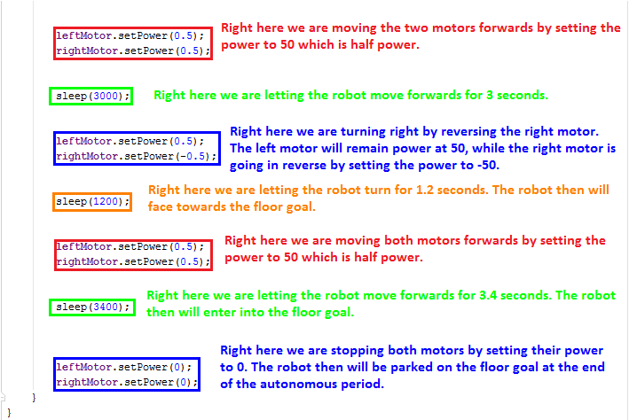

This is the other competition autonomy, it is named “Autonomy2”. This one is for when we are on the red alliance. In this program we are moving the robot forwards and turning left, then we go forwards towards the floor goal and then we park on the floor goal. This is what we have for now but we are trying at the moment to improve and add more to this program to do more obstacles.
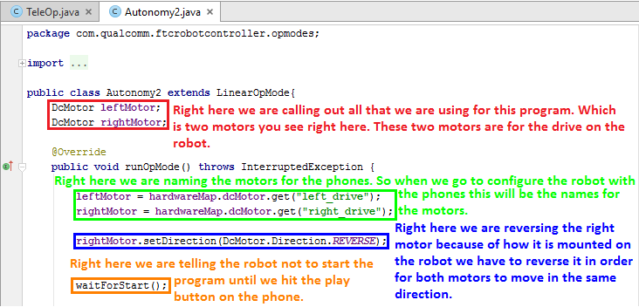
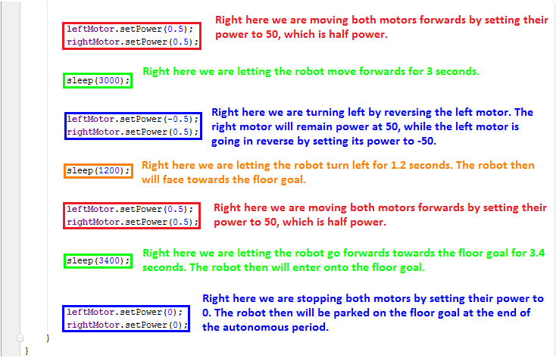

This is our competition TeleOp. It took us a lot of time and effort, there was a lot of bumps in the road but we got passed them and we accomplished a lot! We programmed six motors and two servos. We will explain more in details below!
